**Year 7 Chemistry** Name:____________________

**Mid Topic Test /35**

**Multiple Choice (6 marks)**

***Choose the best answer and mark it on the table to the right***

|  |  |
| --- | --- |
|  | ***Choose the correct answer*** |
| **1** | **A B C D** |
| **2** | **A B C D** |
| **3** | **A B C D** |
| **4** | **A B C D** |
| **5** | **A B C D** |
| **6** | **A B C D** |

**1. Which of the following statements about plasma is not true?**

a. Plasma is only found at temperatures above 6000oC

b. Plasma is common on stars but not on earth

c. Plasma is found deep in the ocean

d. Plasma is the fourth state of matter

**2. Which of the following statements is true regarding Melting Point and Freezing point?**

a. They occur at different temperatures

b. They both happen to solids

c. They both occur at the same temperature

d. They never happen to the same substance

**3. Which of the following can be compressed?**

a. Solids

b. Liquids

c. Gasses

d. Liquids and Gasses

**4. Expansion occurs when solids are heated because**

a. The particles expand when they are heated

b. The particles vibrate faster and take up more space

c. The particles are turning into a liquid

d. Solids contract when they are heated they do not expand

**5. Which of the following statements about the bonds between particles is not true?**

a. The particles in a liquid are not bonded together so they can flow over each other

b. There are no bonds between the particles in a gas

c. The bonds between the particles in a solid are strong

d. All the above statements are true

**6. If you dissolve 5 grams of salt in 10ml of water the concentration will be**

a. 5 g/ml

b. 0.5 g/ml

c. 5 mg

d. 0.5 mg

**Short Answer**

**1.** Read the following description of a glass of orange juice then classify each of the properties mentioned as either physical or chemical. You will not fill all the spaces on the table

*An orange liquid at room temperature, orange juice is slightly acidic and has a freezing point of -2oC. Orange juice will not react with oxygen.*

|  |  |
| --- | --- |
| **Physical Properties** | **Chemical Properties** |
|  |  |
|  |  |
|  |  |
|  |  |
|  |  |

**(5 marks)**

**2.** On the diagram below label the solute, solvent and solution

**(3 marks)**

[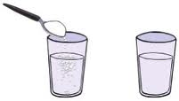](http://www.google.com.au/imgres?hl=en&biw=1280&bih=717&gbv=2&tbm=isch&tbnid=gwd2RuU4pha3bM:&imgrefurl=http://www.morewithmusic.org/2010/05/solute-solvent-solution.html&docid=LFWD2fNUXrkDYM&imgurl=http://4.bp.blogspot.com/_YqNdZWvLaY0/S-d4wKX2oJI/AAAAAAAAAHk/T3Ou27HBcMA/s1600/DissolveSugar.jpg&w=252&h=143&ei=MNlpT77fKq-aiAfQg_ycCg&zoom=1&iact=hc&vpx=434&vpy=406&dur=13&hovh=114&hovw=201&tx=81&ty=70&sig=117597713230240163970&page=2&tbnh=114&tbnw=201&start=12&ndsp=20&ved=1t:429,r:1,s:12)

**3.** Which of the beakers below shows a concentrated solution, and which shows a dilute solution? **(2 marks)**

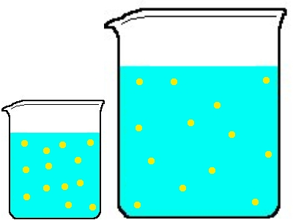

**4. Diagram (11 marks)**

Label each of the diagrams

Label each arrow on this page.

Write either increasing or decreasing on the line in each of the hollow arrows

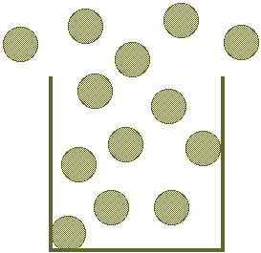

Energy__________________________

Energy__________________________

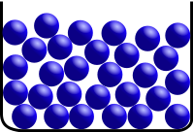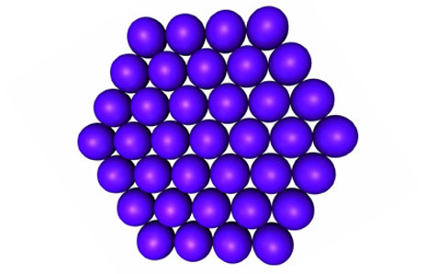

**Paragraph (3 marks)**

Explain why a teaspoon of sugar will dissolve faster in a hot cup of tea than a cup of iced tea.

**Vocabulary (5 marks)**

_____________________________ Water vapour that has condensed to form a cloud of tiny but visible liquid water droplets in the air.

_____________________________ A special change of state where substance changes from a solid to a gas without liquid phase

_____________________________ What a solution is called when the solvent will no longer dissolve in it.

_____________________________ A substance that does not dissolve in another

______________________________ A solution that can be seen through

**End of Test**

**Please read back through your work to check your answers**